
BioAmp v1.5 build Instructions
August 2021

BioAmp v1.5 is an Open-Source single chip Bio-potential amplifier from Upside Down Labs for recording any Bio-potential signal non-invasively. It is compatible with Backyard Brains Spike Recorder, which you can use to record and visualize all the Bio-potential signals. To make your own BioAmp v1.5, you can order the full kit from Tindie or create your own using the BOM and PCB files provided in the GitHub repository. To assemble the PCB you have to place all the components according to the interactive BOM. Step by step instructions for the same are provided below for your ease.

Materials Needed:

- BioAmp v1.5 Bag of Parts.
- Solder and Soldering Iron.
- Magnifying Glass to read labels on Capacitors.
- Silly Putty to hold components while you do the soldering.
- Wire Strippers and Wire Clippers to trim leads.

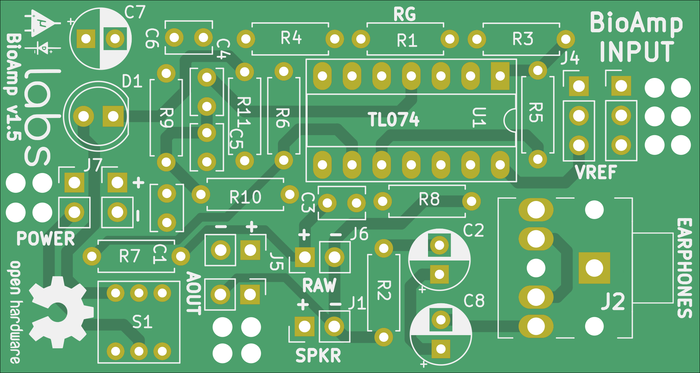

Step by step assembly

1. Resistor 1k

We will start with all the resistors first, for this step you solder a 1k resistor at R11 as shown in the interactive BOM. The image below shows the exact placement of the resistor.

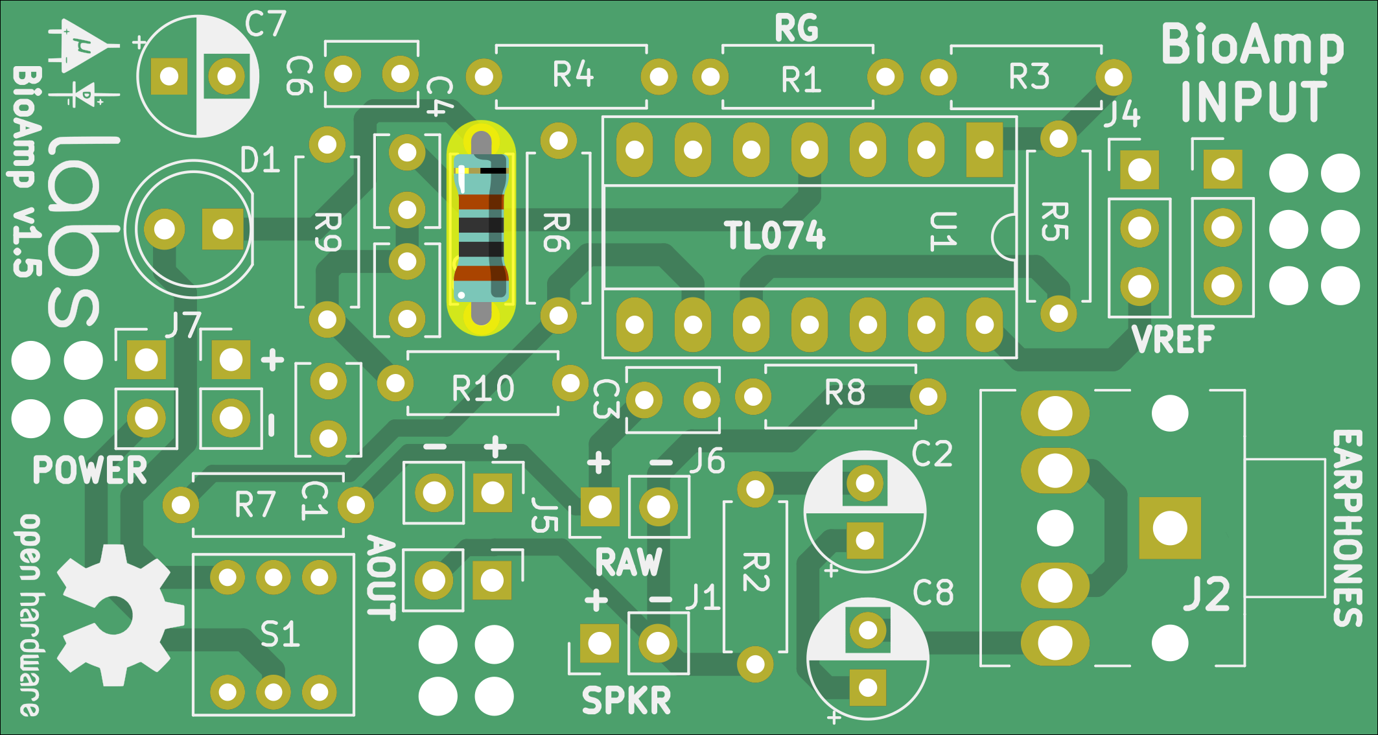
Fig 1. 1k resistor.

2. Resistor 10k

Solder 6 x 10k resistors at R1, R2, R5, R6, R7, and R8.

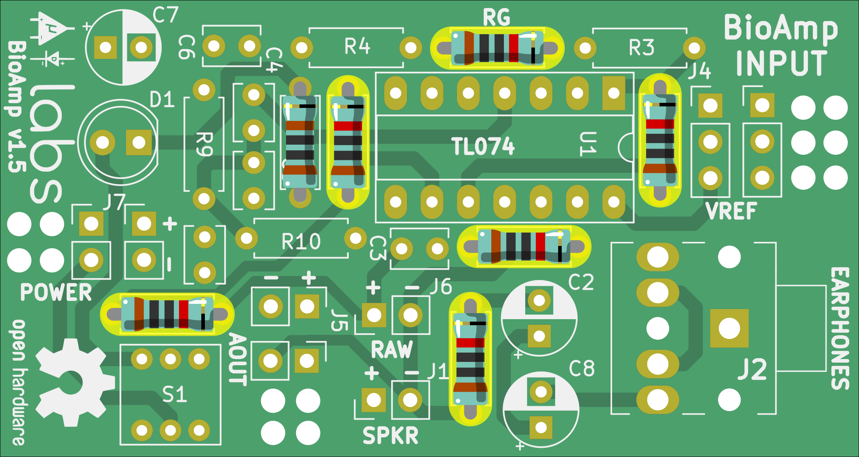
Fig 2. 10k resistors.

3. Resistor 100k

Solder 2 x 100k resistors at R9 and R10.

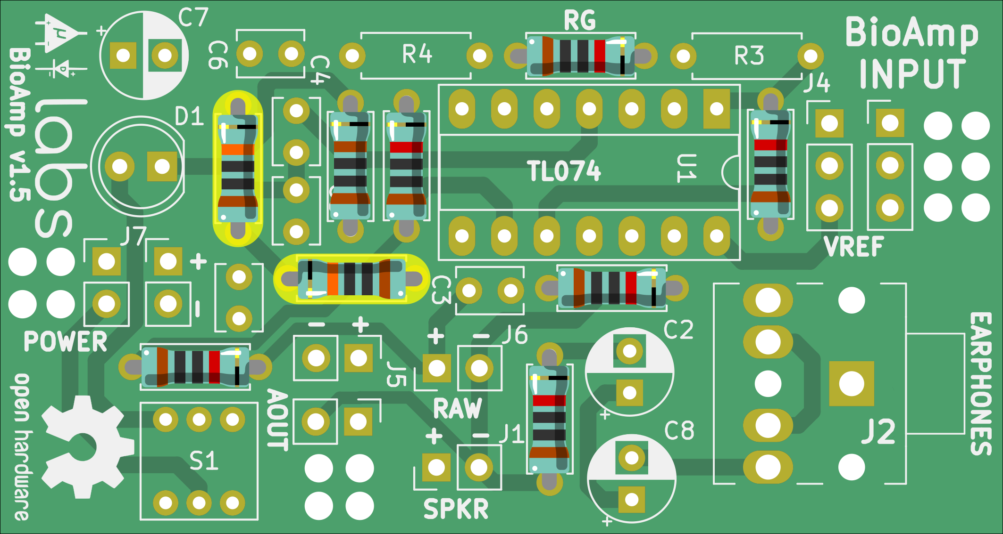
Fig 3. 100k resistors.

4. Resistor 220k

Solder 2 x 220k resistor at R3 and R4.

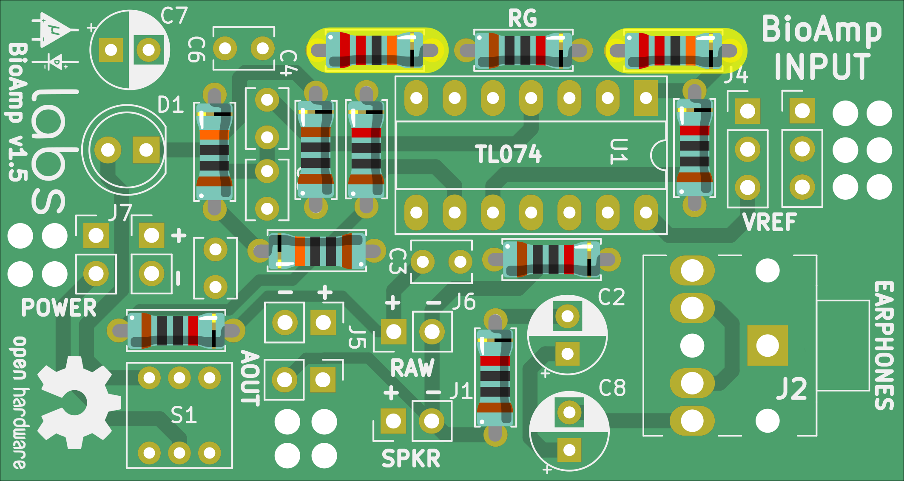
Fig 4. 220k resistors.

4. Capacitor 100nF

Solder 100nF disc capacitors at C1, C3, C4, C5, and C6.

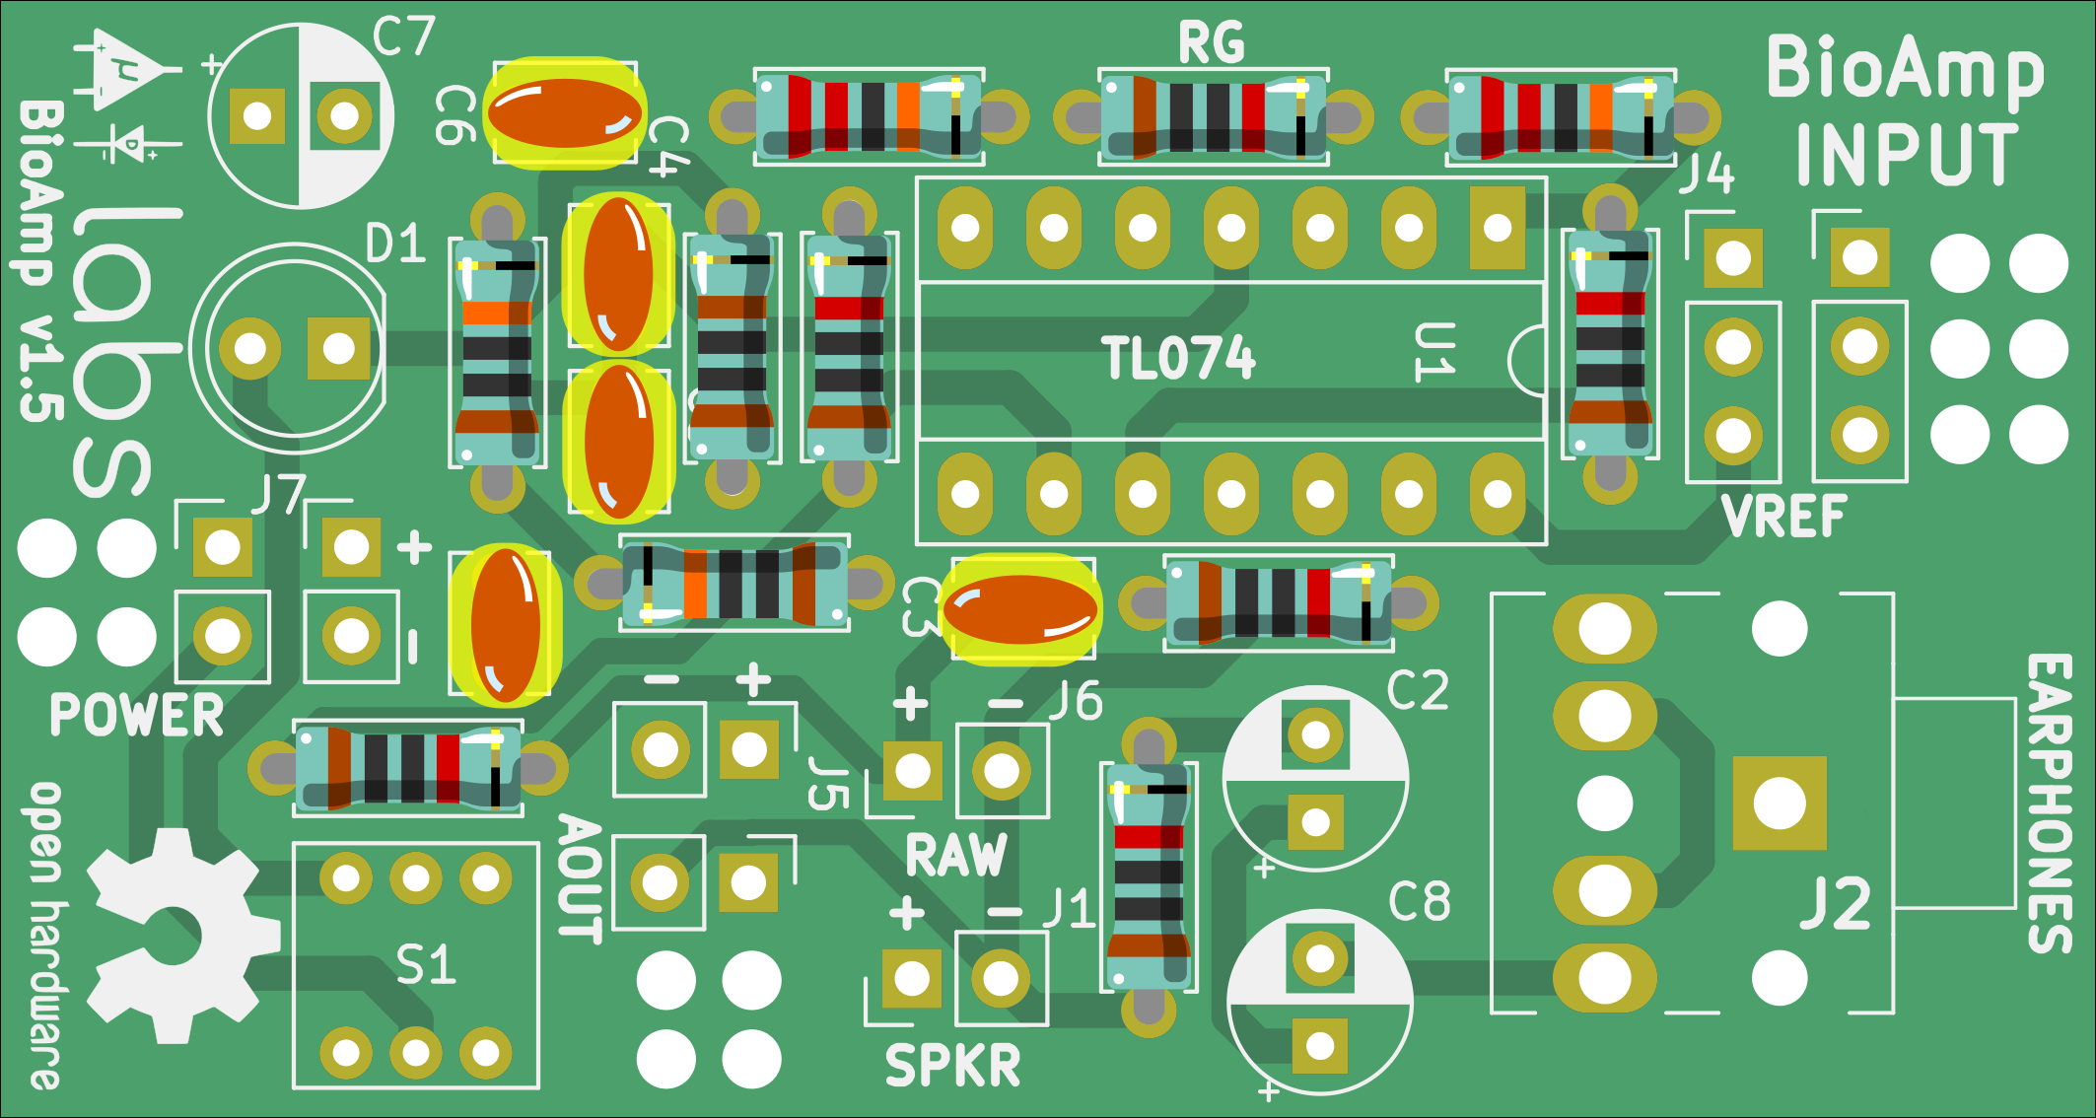
Fig 5. 100nF capacitors.

6. Capacitor 47uF

Solder 47uF capacitor at C2, C7, and C8.

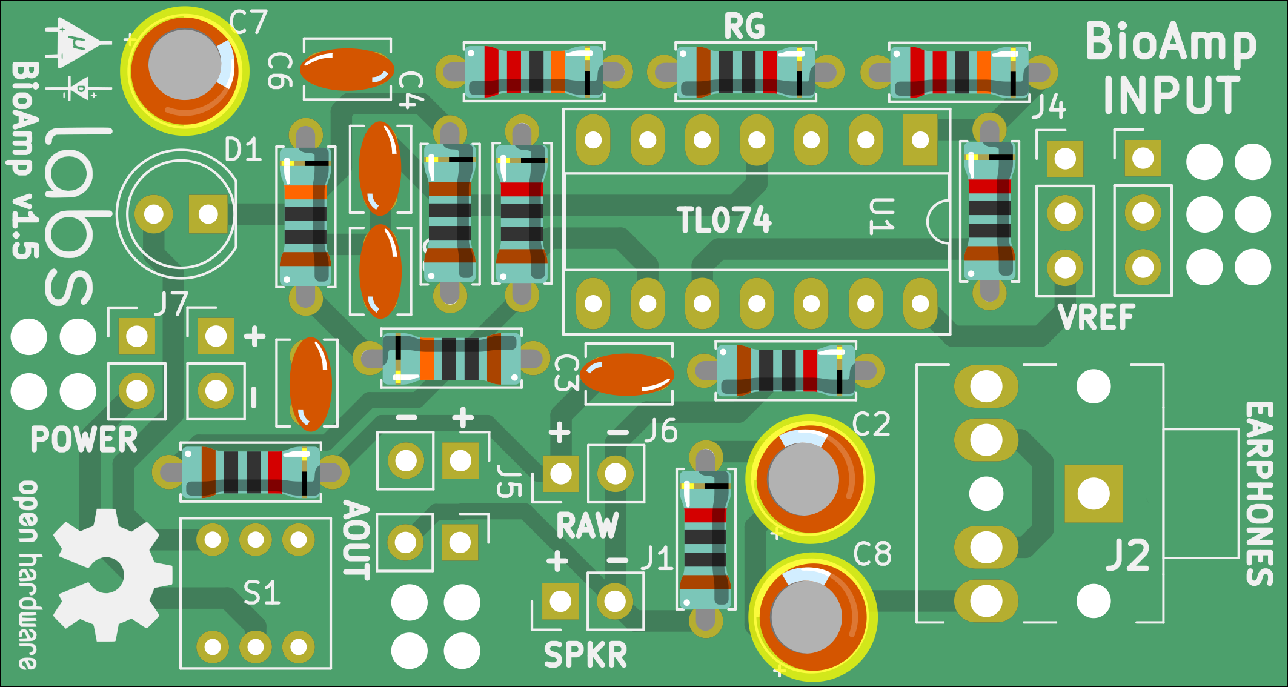
Fig 6. 47uF capacitors.

7. LED

Solder LED at D1.

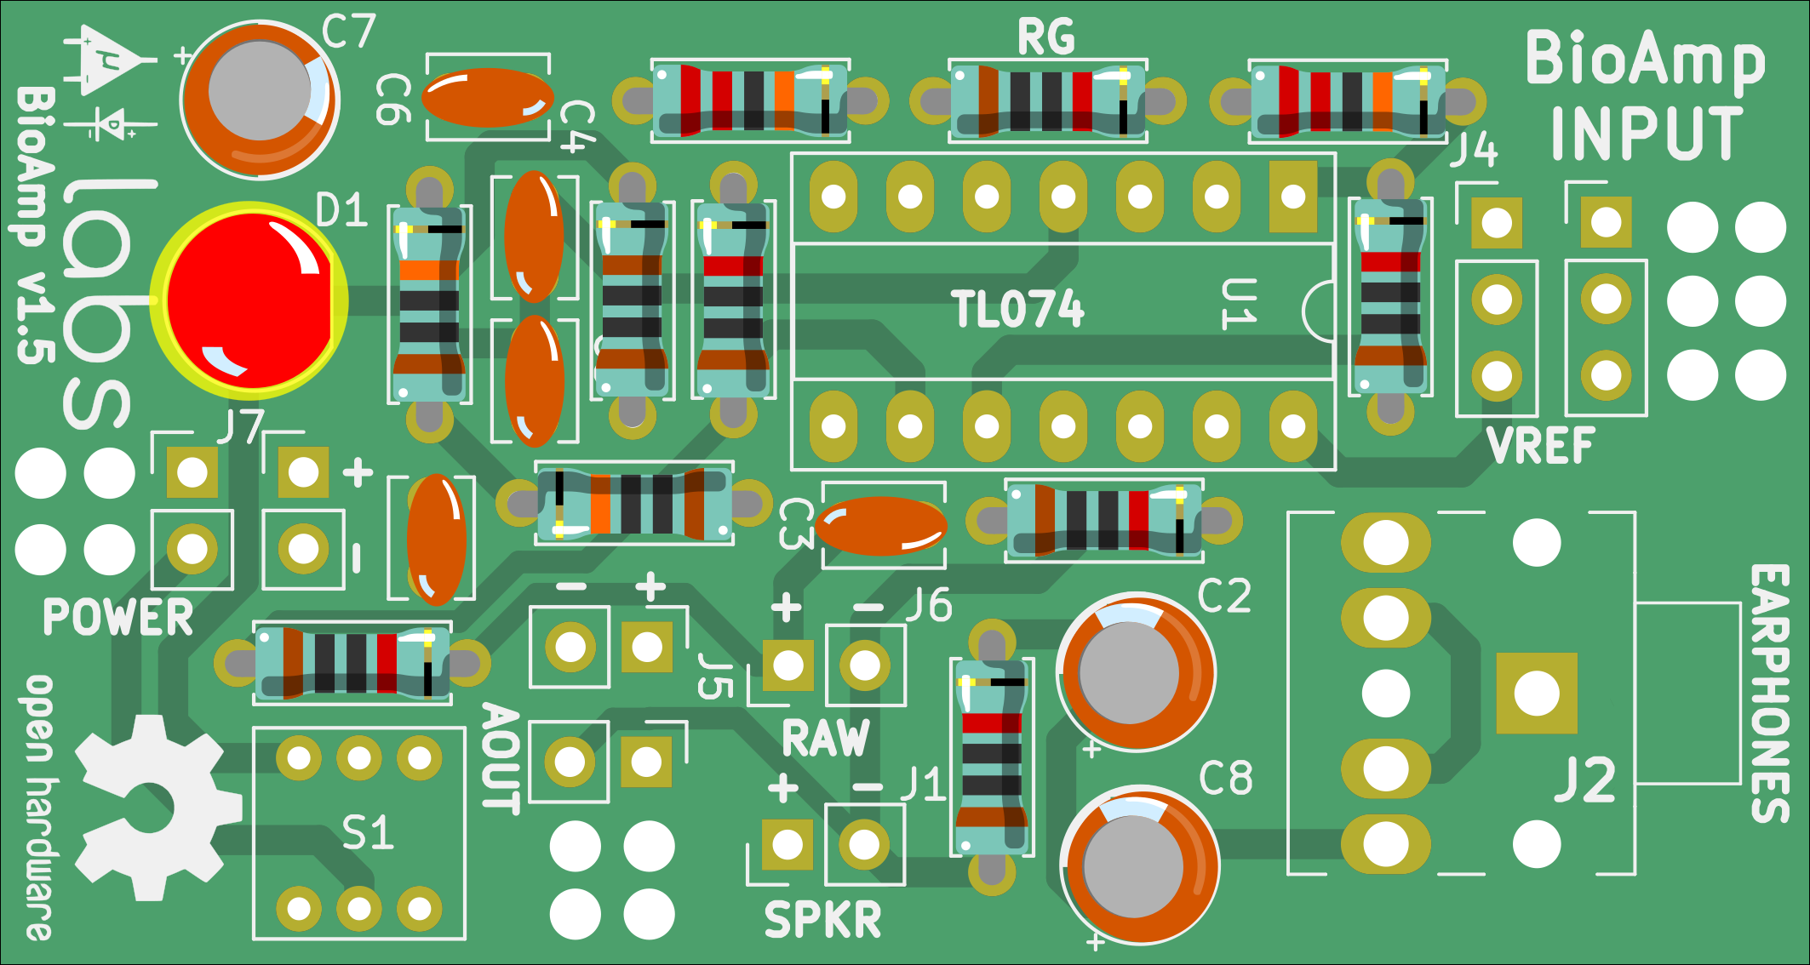
Fig 7. LED.

8. IC socket

Solder IC socket at U1.

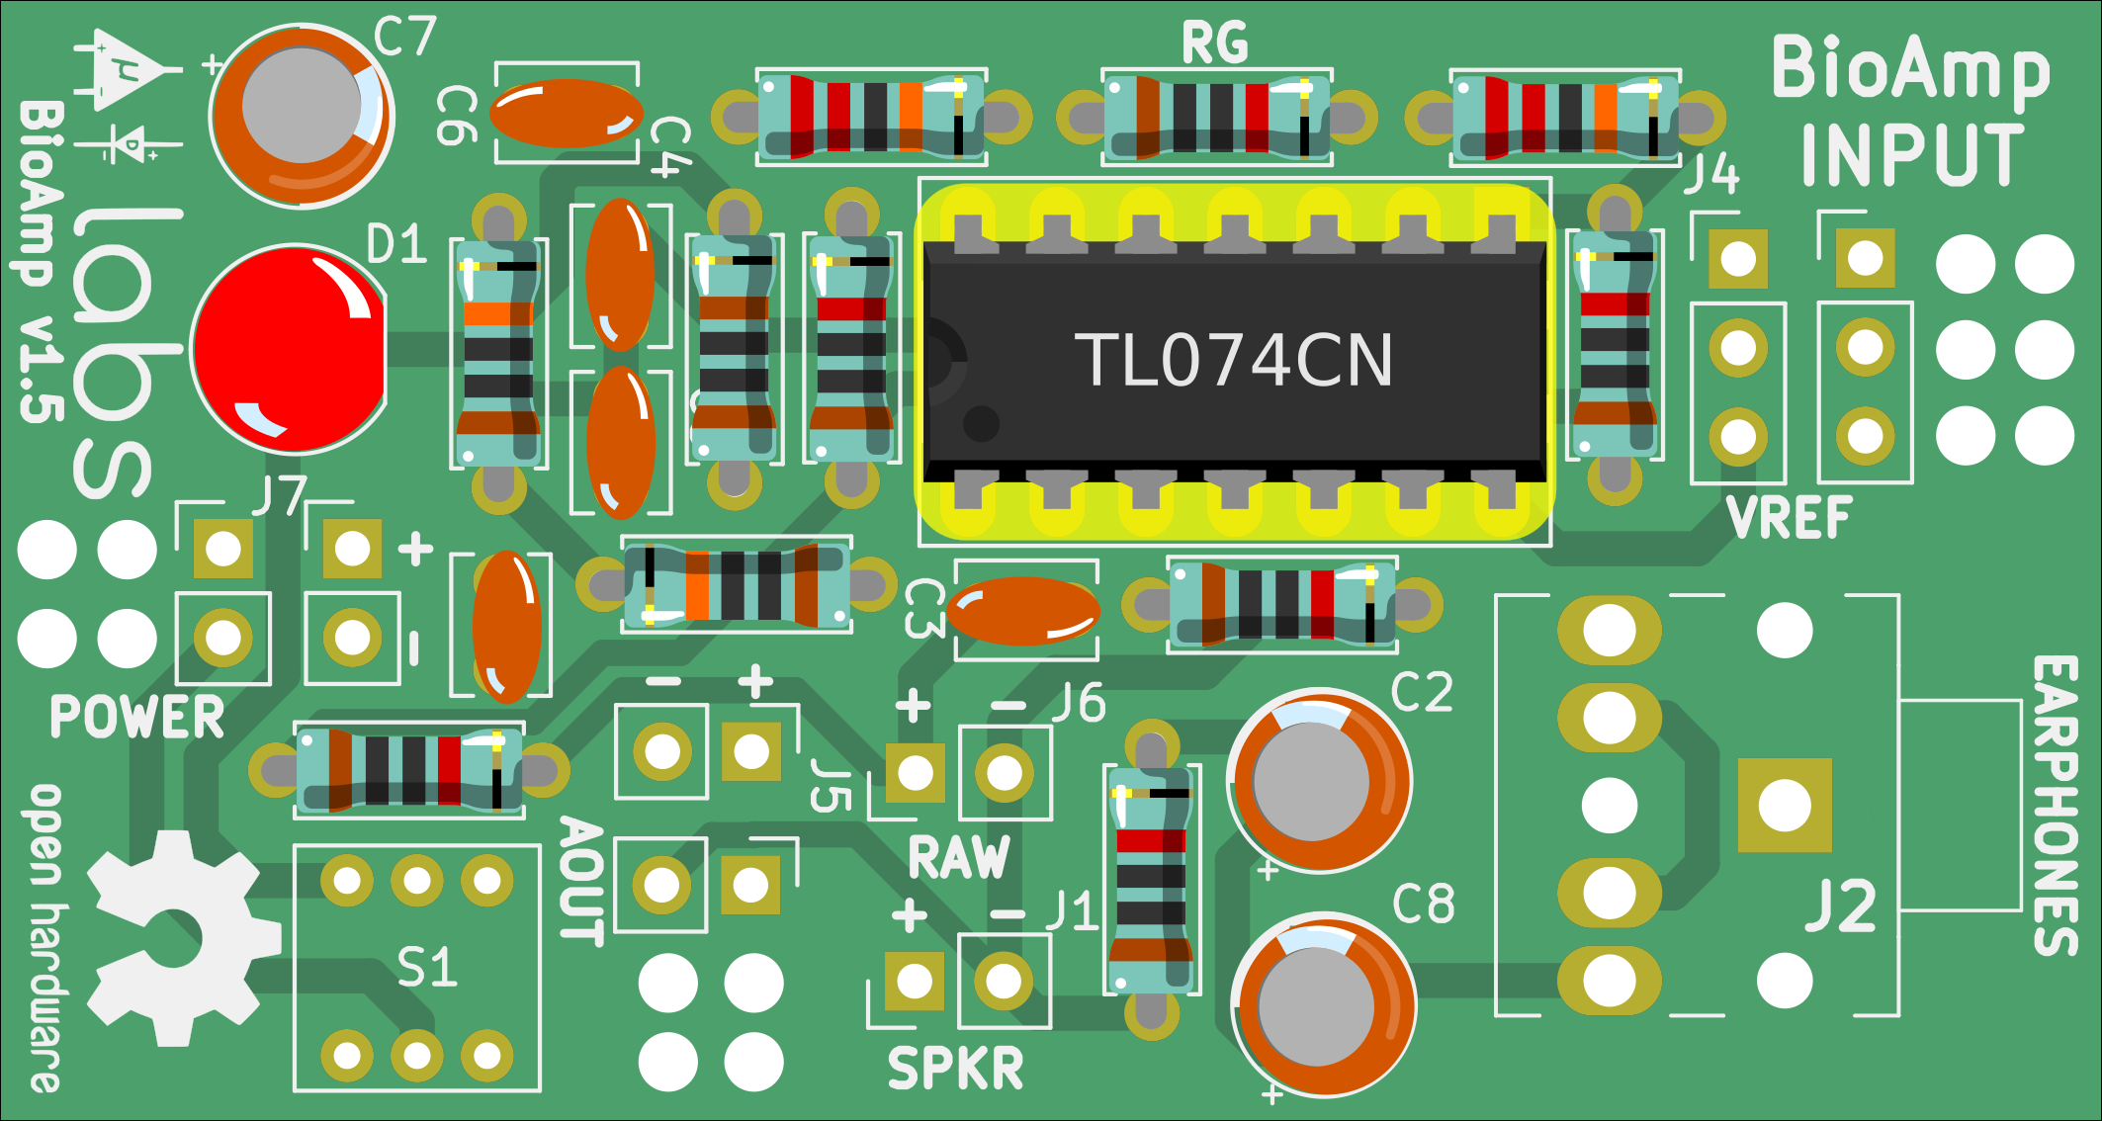
Step 8. IC-socket.

10. DPDT Switch

Solder DPDT switch at S1.

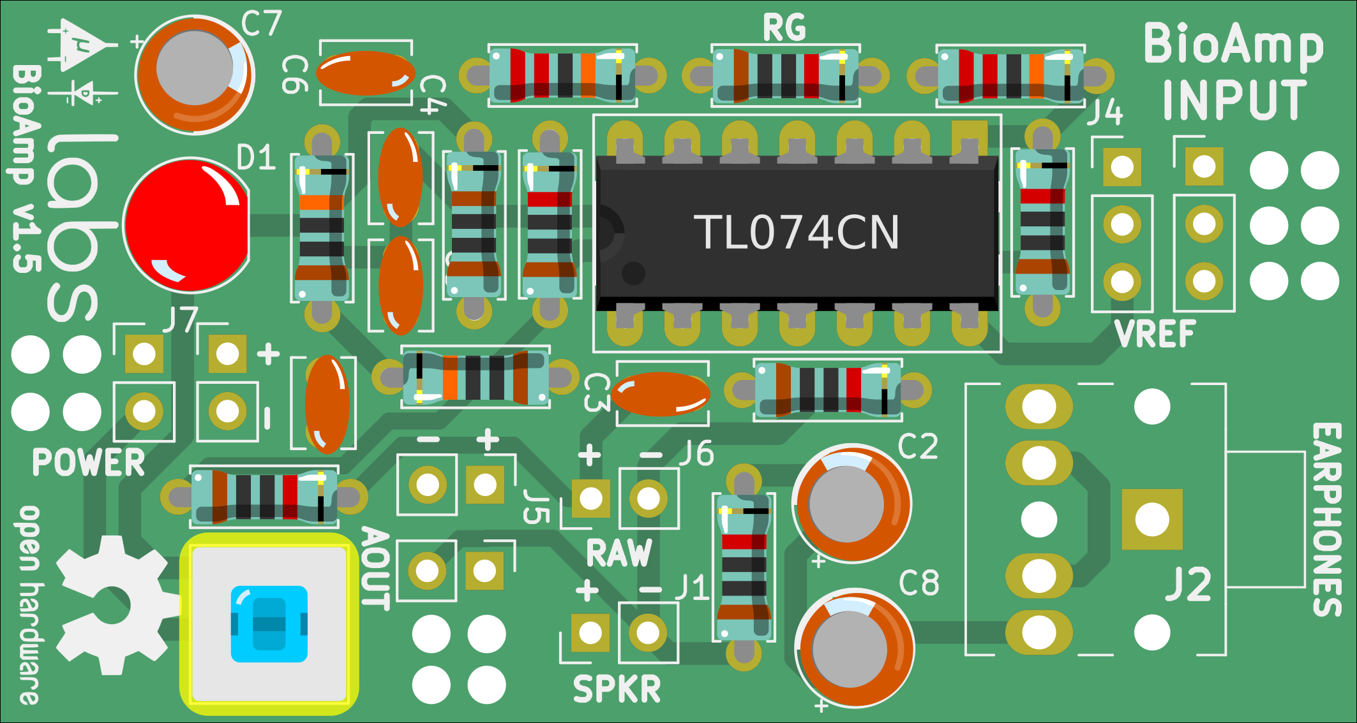
Fig 9. DPDT switch.

10. Headphone Jack

Solder Headphone jack at J2.

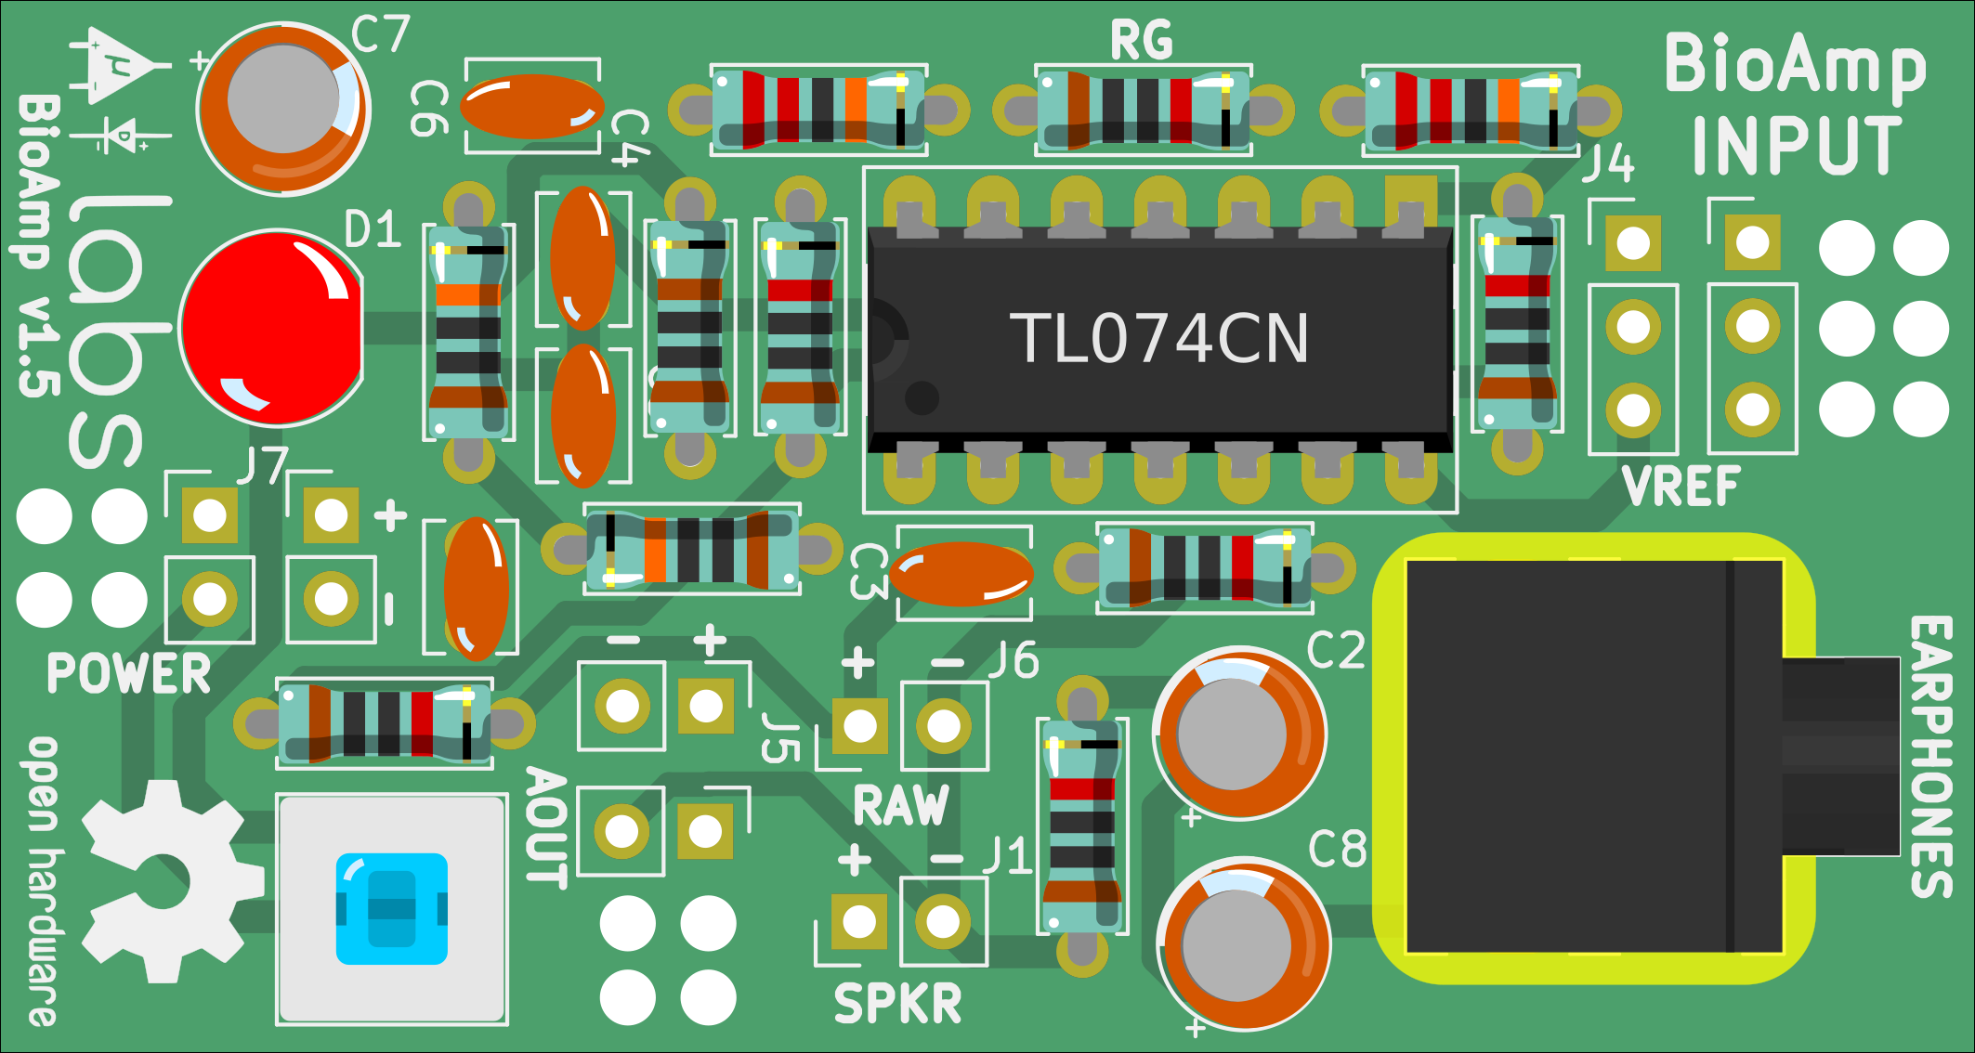
Fig 10. Aux output Headphone jack.

11. Header Pin

Solder 2-Pin and 3-Pin header pins.

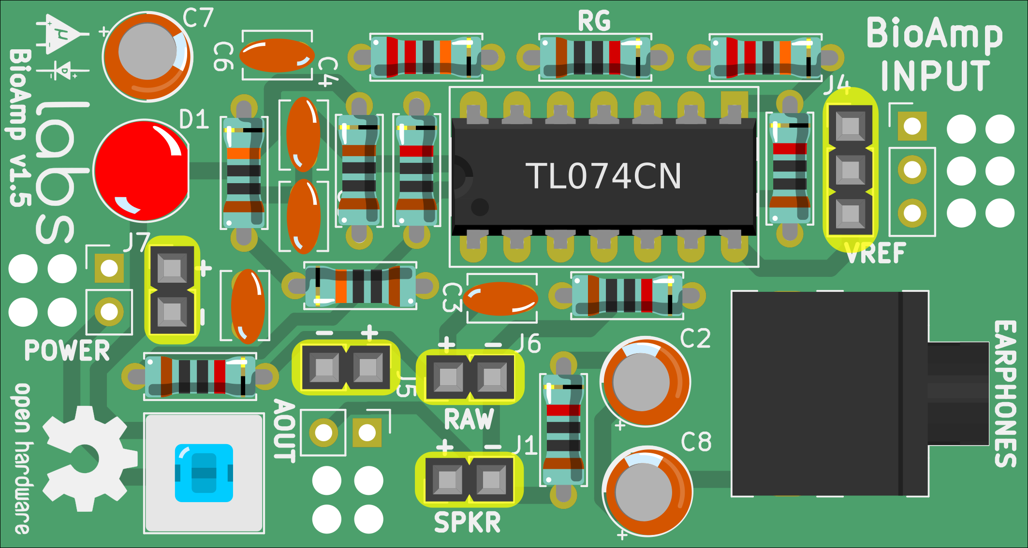
Fig 11. Header pins.
12. Battery snap

Solder 9v Battery snap as shown in the image below, insert the wires from first pair of holes and pull back the wires from second then on to solder them on J7.

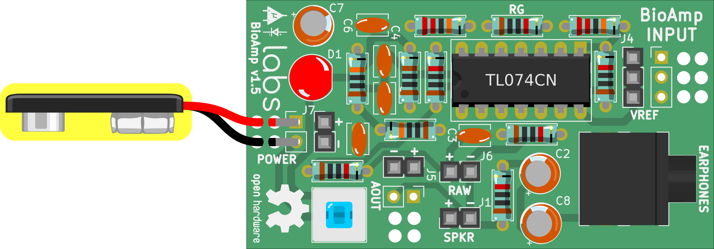
Fig 12. 9v Battery snap.

13. Audio Cable

Un-screw the headphone the metal part of the audio/headphone jack (make) provided in the kit which follows this pinout. It has 4 connections, carefully follow the pinout for soldering the wires.
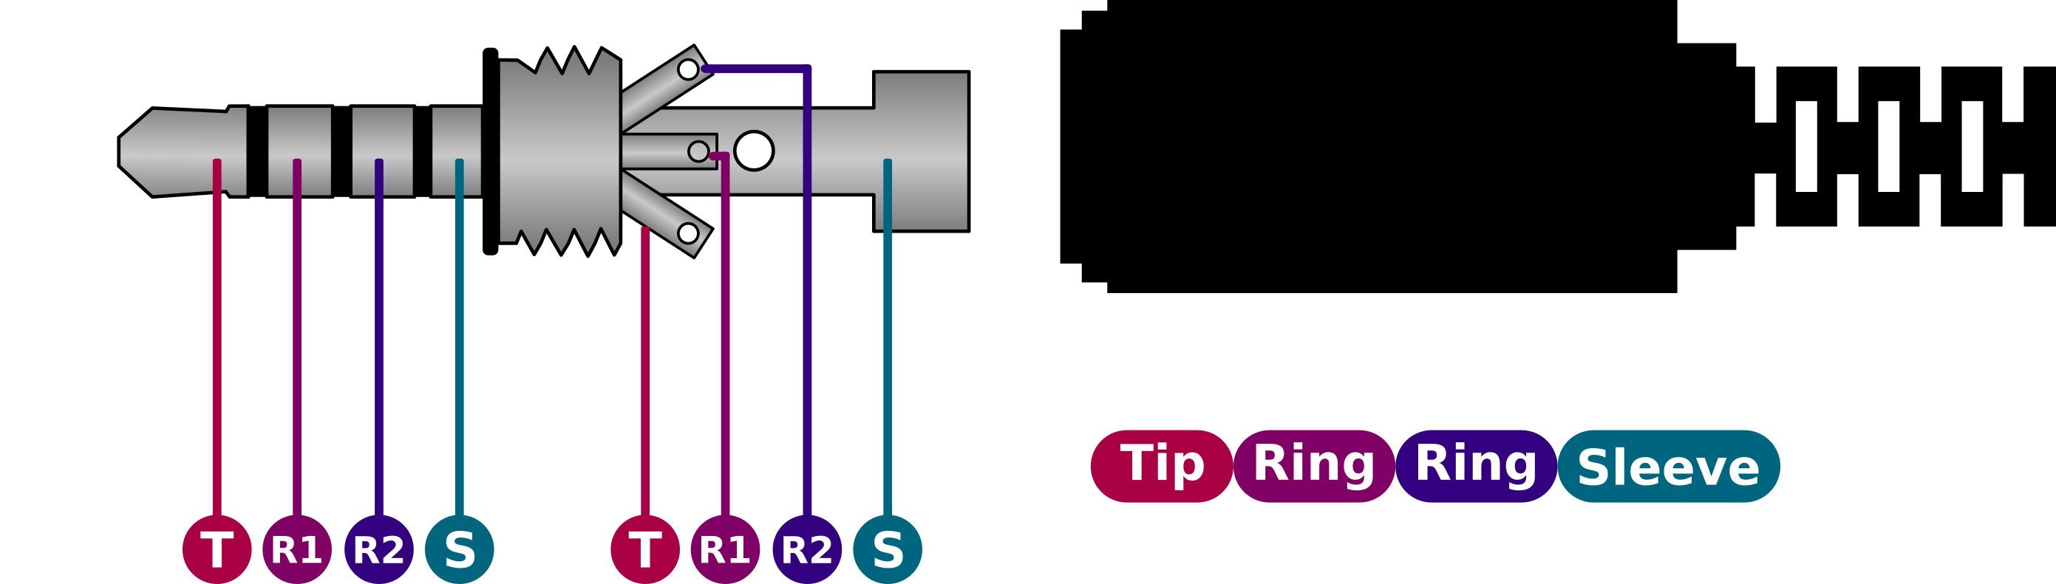
Fig 13A. 3.5mm Audio/Headphone jack pinout

We need to use the microphone pins of this 3.5mm male jack, the connection for the same can be seen in the image below. Solder the blue wire to Ring (R2) and orange wire to Sleeve (S) of the 3.5mm male jack as shown in the picture above. Now Insert the wire from the first pair of holes and then pulling from the second then solder them to J5.

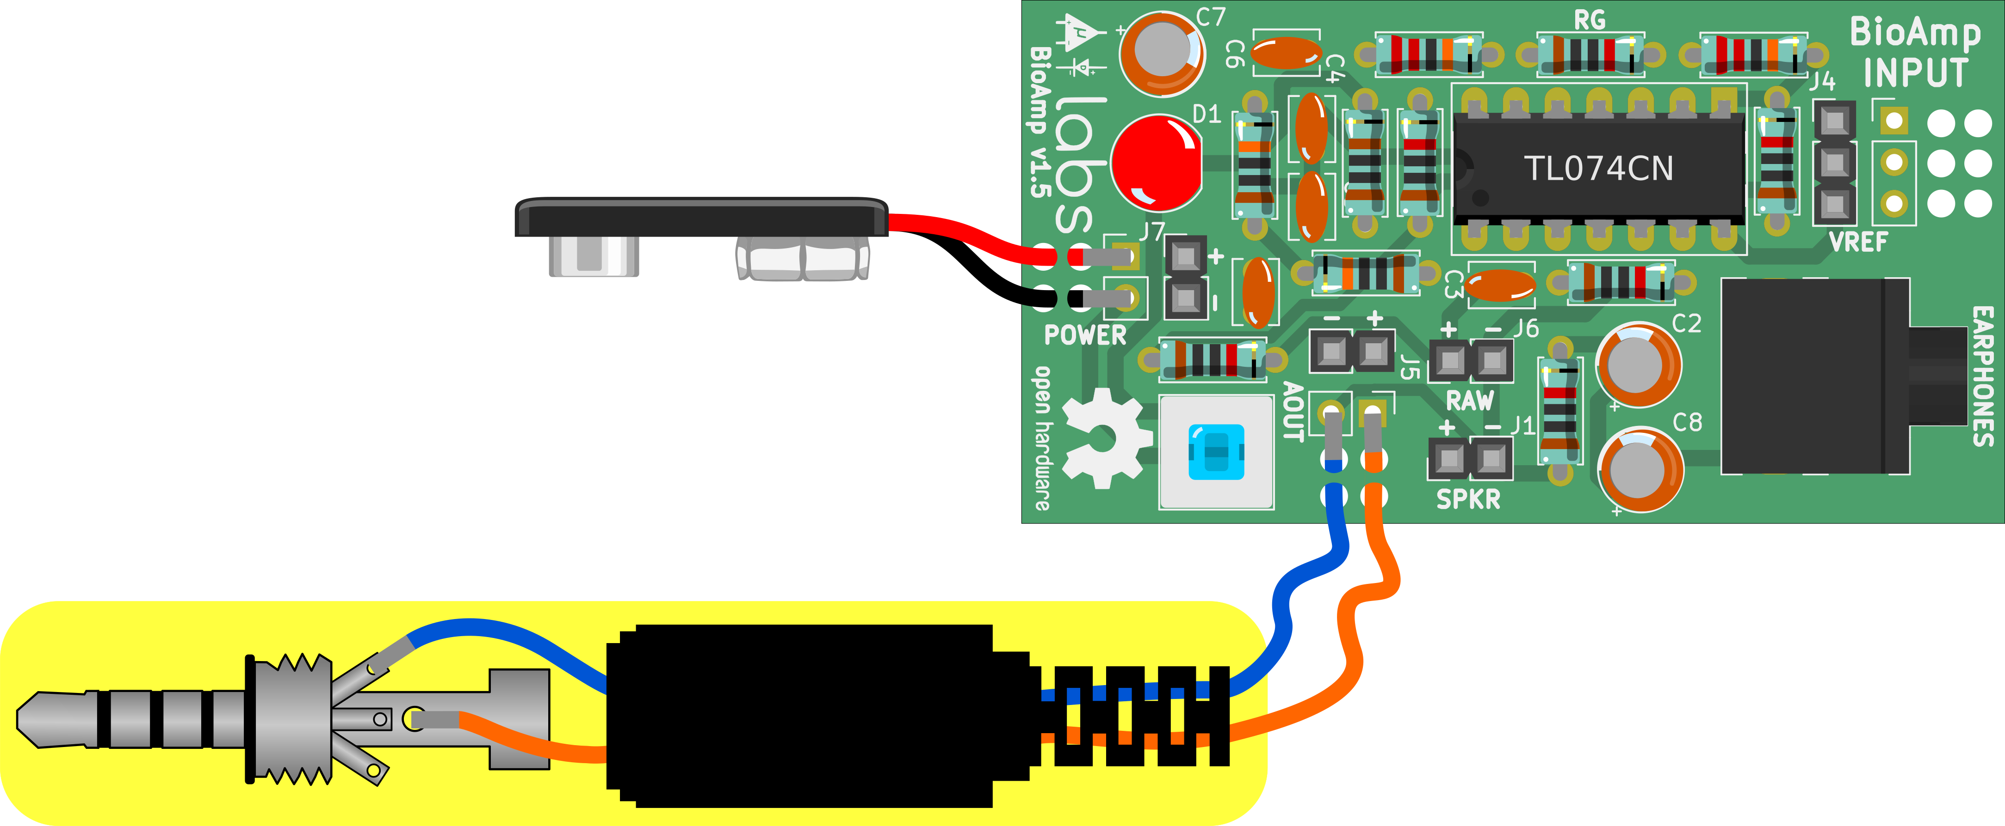
Fig 13B. 3.5mm audio/headphone jack (male).

14. Electrode cable

For Electrode cable,
- Solder all 3 wires (2 Black & 1 Red) to J4 as shown below.
- Remove the alligator clip cover and insert it on the wires.
- Now solder the loose ends of the wire to the clips.
- Insert back the cover from behind.
The final electrode cable should look something like shown in the picture below.

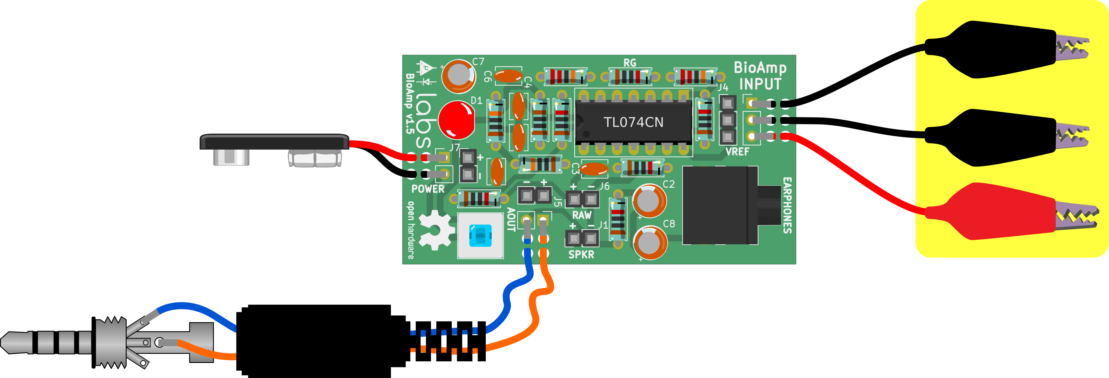
Fig 14. Electrode cable

15. Assembled kit

Now you are ready to use your fully assembled kit in 3 simple steps,
- Connect the module to the 9v battery.
- Attach electrodes to the body using gel electrodes provided in the kit.
- Listen to your muscles using headphones.
You can also record/visualize the signal by using Audacity on your PC or SpikeRecorder on your mobile phone. BioAmp v1.5 also provides options for RAW output and speaker output (require additional speaker amplifier).

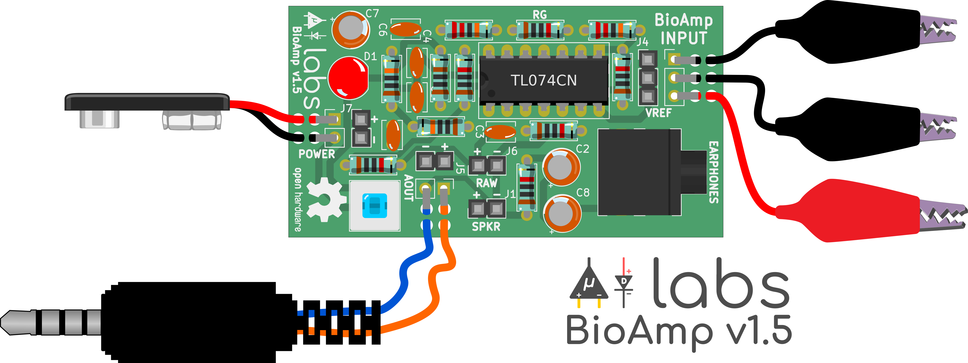
Fig 15. Fully assembled BioAmp v1.5

